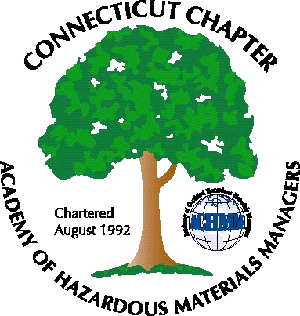Connecticut Chapter of AHMP Inc.
Mailing Address: CT ACHMM P.O. Box 604 Plainville, CT 06062
www.ctachmm.org

Chapter Membership Form

Please fill out the form below and send it and the Chapter $40 membership fee to.

John Murray CHMM CSP CIH
CTAHMP Membership Chair
P.O. BOX 604
PLAINVILLE, CT 06062
Fax: 413.794.1403
Email: John.Murray@baystatehealth.org
Chapter email: contactus@ctachmm.org

Name:
Organization:
Work Address:
City:
State:
Zip Code:
Work Telephone#:
E-Mail:
Mail To:
Home Or Work
Home Address:
City:
State:
Zip Code:
Home Telephone #:
Home E-Mail:
Do you want to be on the CTACHMM Website Listing |  | Yes □ | No □

