Connecticut Chapter  of the  Alliance of Hazardous Materials Professionals  Mailing Address: CTACHMM P.O. Box 604 Plainville, CT 06062  www.ctachmm.org | 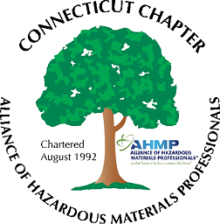

Minutes of the Board of Directors Meeting

Attendees: Whyndam Abrams, Jan Marnicki, Stuart Manley, Paul Simonetta
9/20/2023
8:30 AM – 10:00 AM
Agenda –
- Jan recapped the recent AHMP National Conference which she attended as the Chapter delegate. She reported a generally good conference, with in-person attendance required at each technical session (no videos available this year). The Chapter was recognized for its 30 year anniversary.
- The New England Chapter has reached out for a co-sponsership of a virtual meeting in November, on “The Value of the CHMM Certification,” to be presented by Mathew Hackman. Whyndam and Jan will attend the planning session.
- Paul noted that clients are asking about Sustainability programs, that their own customers are requiring or inquiring about. Paul will present a Sustainability Update at our holiday meeting, tentatively scheduled for December 13. The meeting will be either at JTimothy’s of at the GHD Plainville office, depending on venue cost. Stuart will obtain pricing from the restaurant.
- 2024 events could be a tour of Two Roads Brewery in Stratford or of a winery in Somers, a solar power facility, or a E-waste recycling facility.
- Stuart reported the bank account balance is at approximately $1,142.71. He noted our bank is charging a $10 monthly account maintenance fee. He will try to get this waived, or investigate switching banks. We should start receiving chapter dues from national in January.
- John Murray will be contacted for an up-to-date membership count.
- A new Chapter affiliation agreement will need to be signed by Stephanie as our President. Jan and Stuart will prepare the document.

The meeting was adjourned at 10:00 AM.

-Respectfully Submitted by Whyndam Abrams, Secretary-CTAHMP-

