Connecticut Chapter  of the  Alliance of Hazardous Materials Professionals  Mailing Address: CTACHMM P.O. Box 604 Plainville, CT 06062  www.ctachmm.org | 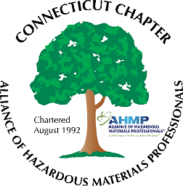

Minutes of the Board of Directors Meeting

Attendees: Whyndam Abrams, Jan Marnicki, Stuart Manley, Nick Zackeo, Paul Simonetta
1/31/2023
8:30 AM – 10:00 AM
Agenda –
- Possible topic for the next General Membership meeting was discussed. A tour of the Mystic Aquarium operations may be possible, Jan will contact them. Tour at 3:00 on a Tuesday, Wednesday or Thursday would be ideal, followed by a meal at a nearby restaurant.
- The following meeting could be a networking event at a local brewery. This could include a regulatory update on trash disposal in CT (MIRA closing), new release reporting regulations, and the impacts of the severe ozone reclassification of certain counties.
- Another event could be a community stewardship event, such as a river clean-up. Possibly partnering with another organization such as Trout Unlimited.
- Stuart reported the bank account balance is at approximately $1,100. This will increase slightly as yearly National memberships are processed.
- John Murray will be contacted for an up-to-date membership count.
- Stuart will prepare the tax return in May.
- New website host such as WIX or SquareSpace was discussed. This would be an involved transition.
- Jan will be attending the August National AHMP meeting in Omaha, NE, as the Chapter delegate.

The meeting was adjourned at 10:00 AM.

-Respectfully Submitted by Whyndam Abrams, Secretary-CTAHMP-

