Connecticut Chapter  of the  Alliance of Hazardous Materials Professionals  Mailing Address: CTACHMM P.O. Box 604 Plainville, CT 06062  www.ctachmm.org | 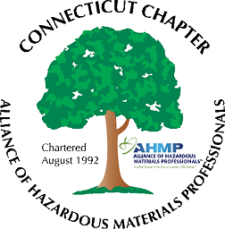

Minutes of the Board of Directors Meeting

Attendees: Whyndam Abrams, Jan Marnicki, Stuart Manley, Laura Zadrick
3/11/2022
7:30 AM – 9:00 AM
Agenda –
- It was noted that a number of significant retirements are occurring at DEEP, including within the water bureau.
- Possible topics for the next General Membership meeting was discussed. Jan will look at recent Cyber Chapter presentations for possible topics. A regulatory update could round out the presentation, including recent UST regulation revision, ELUR changes, release reporting regulation that was effective March 4, 2022, EPA Stormwater permit, and proposed PCB regulation revision.
- Arranging a tour of a tourist attraction, such as an amusement park, museum, or other venue, or of a manufacturing facility could be a meeting for later in the year.
- Stuart reported the bank account balance is at approximately $1,300. This will increase as yearly National memberships are processed.
- John Murray will be contacted for an up-to-date membership count. It was reported that two newly-minted CHMMs have joined the Chapter.
- Jan will be attending the March National AHMP meeting in Las Vegas, NV, as the Chapter delegate. The Chapter will reimburse for the discounted registration fee.

The meeting was adjourned at 9:00 AM.

-Respectfully Submitted by Whyndam Abrams, Secretary-CTAHMP-

