Connecticut Chapter  of the  Alliance of Hazardous Materials Professionals  Mailing Address: CTACHMM P.O. Box 604 Plainville, CT 06062  www.ctachmm.org | 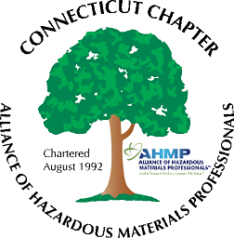

Minutes of the Board of Directors Meeting

Attendees: Whyndam Abrams, Jan Marnicki, Stuart Manley, Paul Simonetta, John Murray
8/12/2021
7:30 AM – 9:00 AM
Agenda –
- John Murray indicated Chapter membership is at sixteen. Several individuals will be reminded to pay their Connecticut Chapter membership.
- Possible topics for the next General Membership meeting was discussed: Stuart mentioned that the Release Reporting Regulations have not had any movement lately. Whyndam mentioned that the Underground Storage Tank regulations revision is at the Legislative Review stage and should be issued shortly. The main activity on the water permit changes were last October, with the issuance of the Significant Industrial Users and Miscellaneous Industrial Users General Permit. John mentioned an interesting under-river drilling project in Springfield, MA, that could be an interesting tour. John will reach out for a possible mid-September date.
- For the foreseeable future, General Membership meetings will either be held outdoors or virtual over Zoom.
- Stuart reported the bank account balance is at approximately $1735. This will increase slightly as a few more Chapter dues are paid.
- Whyndam reported his access issues with updating the website. Web host GoDaddy was contacted and issue was a new ftp access password. Website has now been updated with the latest job postings. Ftp password will be provided to Stuart.
- The National AHMP Conference for 2021 was held virtually in July. Jan reported the 2022 meeting is still scheduled for in-person in Las Vegas, NV.

The meeting was adjourned at 9:00 AM.

-Respectfully Submitted by Whyndam Abrams, Secretary-CTAHMP-

