Connecticut Chapter  of the  Alliance of Hazardous Materials Professionals  Mailing Address: CTACHMM P.O. Box 604 Plainville, CT 06062  www.ctachmm.org | 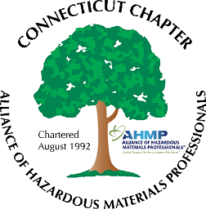

Minutes of the Board of Directors Meeting

Attendees: Stephanie Boyd, Whyndam Abrams, Jan Marnicki, Stuart Manley, Paul Simonetta, Nick Zackeo
3/12/2021
8:30 AM – 9:30 AM
Agenda –
- As previously provided by John Murray for the annual report, Chapter membership is at twenty-three. Thank you to Jan for preparing and submitting the annual report.
- Possible topics for the next General Membership meeting was discussed: Stuart mentioned that the Release Reporting Regulations draft has been issued and would be a timely topic. Stuart, Paul, and Nick will inquire at their respective firms (GHD, Triton, and Arcadis) if someone would be willing to present on this topic. Once a speaker is established, a General Membership meeting will be scheduled for April or early May. Meeting will either be virtual or could be at an outdoor location depending on a suitable venue.
- An outdoor networking event will be scheduled for June or July. Ideally this would be at a brewery in a central location and with a scenic vista. Kinsmen Brewery in Plantsville was suggested as a possible venue.
- Stuart reported the bank account balance is at approximately $2,000. More dues should be distributed from National AHMP as national and chapter dues are paid.
- Whyndam reported his bank card has arrived and will be used next to pay the annual Chapter State incorporation registration fee. Anther on-going expense is the GoDaddy website server fee. Website access issues will be investigated by Whyndam and Stuart.
- The type of meeting of the National AHMP for 2021 is still being determined. Hybrid or virtual meeting is likely. The 2022 meeting will be in Las Vegas.

The meeting was adjourned at 9:30 AM.

-Respectfully Submitted by Whyndam Abrams, Secretary-CTAHMP-

