Connecticut Chapter  of the  Alliance of Hazardous Materials Professionals  Mailing Address: CTACHMM P.O. Box 604 Plainville, CT 06062  www.ctachmm.org | 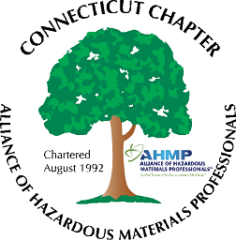

Minutes of the Board of Directors Meeting

Attendees: Stephanie Boyd, Whyndam Abrams, Jan Marnicki, Stuart Manley, John Murray, Paul Simonetta
January 31, 2020
7:30 AM – 9:00 AM
Agenda –
- Next General Membership meeting scheduled for March 25, 2020, at Fuss & O’Neill. The topic will be FTIR analyses, presented by Joel Myerson, President of Martech Controls. Restaurant following the meeting to be determined.
- Possible topics for subsequent General Membership meeting discussed: tour Stanley Black & Decker in East Longmeadow, MA, tour of MGM Springfield, tour of Quantum Biopower (food digester facility), or tour of Baystate Health Animal Care facilities.
- The Chapter Annual report to be submitted 1/31/2020. (Completed)

- Stuart reported the bank account balance remains steady. More dues should be distributed from National AHMP as national and chapter dues are paid.

- John reported there are twenty-five paying members. People often renew through General Membership meeting sign-ups, so membership is expected to increase after the March 25 meeting. Status of IHMM notification to the Chapter for new CHMMs granted in the Connecticut area is unknown.

- John noted that companies have been including the CHMM designation in position descriptions for new hires.

- EPA recently included PFAS compounds in the Form R reporting requirements. Massachusetts is proposing a MCL for drinking water companies.

- National AHMP meeting will be in Nebraska in Summer 2020.

The meeting was adjourned at 9:00 AM.

-Respectfully Submitted by Whyndam Abrams, Secretary-CTAHMP-

