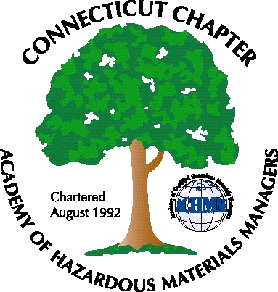 Connecticut Chapter of the

Academy of Certified Hazardous Materials Managers

Minutes of the Board of Directors Meeting

Attendees: Whyndam Abrams, Jan Marnicki, Stuart Manley
March 1, 2019
7:30 AM – 9:00 AM

Agenda –
- Possible topics for next General Membership meeting discussed, RCRA and DOT training was deferred, next meeting with be a Site Investigation case study. Stuart Manley from GHD will present. Location will be J Timothy’s, on April 4, depending on availability. A “Hold the Date” email to be sent to General Membership-done.

- We would like to do a tour for the following General Membership meeting, if possible. Last year’s tour of Clean Earth Technology was well-received. Brewery Tour with Food Truck availability was an option.

- To increase membership participation in Board of Directors activities, Stuart indicated we should send invite to the General Membership. Social Media was discussed as a way to increase participation in Chapter Activities.

- Stuart reported there is $???? In the bank account

The meeting was adjourned at 9:00 AM.

-Respectfully Submitted by Whyndam Abrams, Secretary-CTACHMM

