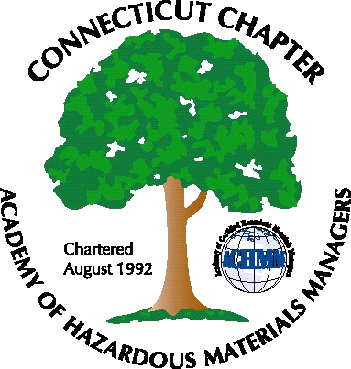 Connecticut Chapter of the

Academy of Certified Hazardous Materials Managers

Minutes of the Board of Directors Meeting

Attendees: Whyndam Abrams, Jan Marnicki, Stuart Manley, John Murray, Stephanie Kelleher-Boyd,
March 9, 2018
7:30 AM – 9:00 AM
Agenda –
- John Murray discussed his email to the list, reminding AHMP members to link the Connecticut Chapter to their profile. This ensures that the Chapter membership option appears on the annual dues invoice. Sixteen members have paid for this year. 8 from National, 8 directly. Our email distribution list is at 172. National has been sending us the Chapter dues money.

- There was a question if we have a “Retired” membership option. At this point there is no such option.

- The annual report needs to be completed. The report was finalized during the meeting and submitted to AHMP. Submission of the annual report is necessary to remain a Chapter in good standing, and for AHMP to collect Chapter dues during annual National membership invoicing.

- Tax returns need to be posted on website home page (in addition to BOD page), to allow member access, as required by our non-profit status.

- There is less than $1,000 presently in the Chapter bank account. It was noted that PayPal does not automatically deposit funds into the bank account, as Square does. PayPal requires manual transfer through the PayPal account. Password needs to be shared.

- The upcoming General Membership meeting is scheduled for some time in April. Jan and John will look into brewery or distillery tours.

- The following General Membership meeting will be scheduled for September. Topic may be tour of Clean Earth (former Phoenix) contaminated soil processing facility in Plainville.

The meeting was adjourned at 9:00 AM.

-Respectfully Submitted by Whyndam Abrams, Secretary-CTACHMM

