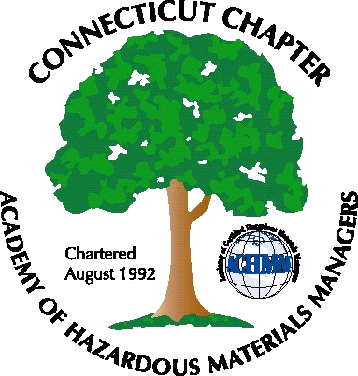 Connecticut Chapter of the

Academy of Certified Hazardous Materials Managers

Minutes of the Board of Directors Meeting

Attendees: Whyndam Abrams, Stuart Manley, John Murray,
September 9, 2017
7:30 AM – 8:45 AM
Agenda –
- The upcoming General Membership meeting, scheduled for September 14 at J Timothy’s was discussed. Paul Simonetta and Laura Zadrick will present RCRA training, which will include updates to the Generator improvements rule. This training will have a quiz and will satisfy annual RCRA refresher training requirements. John will send another reminder.

- An effort will be made at the General Membership meeting to recruit new Board members. President or Vice-President position will be open, depending on if current Vice-President will be able to assume President position.

- Next General Membership meeting(s) will be scheduled for November and/or December. Topic may be recent DEEP inspection activities.

- The recent AHMP National meeting in Fort Worth, TX, attended by Whyndam, was discussed, as of good quality, but lightly attended from Connecticut. Presentations, vendor show, and tours were useful and interesting. Next year’s National conference will be in Reno, NV.

- Stuart will obtain updated Expression Web software to be able to edit the CTACHMM website, and to be able to post the weekly Job Postings as a back-up.

The meeting was adjourned at 8:45 AM.

-Respectfully Submitted by Whyndam Abrams, Secretary-CTACHMM

