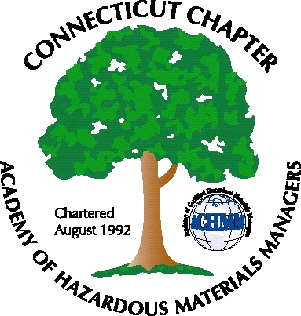 Connecticut Chapter of the

Academy of Certified Hazardous Materials Managers

Minutes of the Board of Directors Meeting

Attendees: Laura Zadrick, Whyndam Abrams, Stuart Manley, John Murray, Stephanie Kelleher-Boyd, Paul Simonetta, Nick Zackeo
May 19, 2017
7:30 AM – 8:45 AM
Agenda –

- Regulatory update: The proposed updates to the Transfer Act have stalled. Staffing issues at DEEP continue to be a concern. Public hearing on CHMM incorporation into the Comprehensive General Permit is still trying to be scheduled. Connecticut Chapter of AWA still working on technical revisions with DEEP Water Bureau staff. Paul/Whyndam to contact DEEP.
- Next General Meeting discussed, have been unable to arrange facility tour. It was decided next meeting will be Hazardous Waste Update/Training. Laura, Paul, Nick and John will prepare presentation. Training will meet annual RCRA refresher requirements and a certificate will be issued. Meeting scheduled for July 12, 2017.
- Whyndam reported annual Secretary of State registration has been filed
- New Chapter credit cards have been issued to Stuart and Whyndam.
- New Members/active membership: Thirteen paid members for 2017, of these twelve are returning members, one is new member. Expected to increase with next General Membership meeting.
- Treasury Update – balance is approximately $1,700.
- Mail: -One check from AHMP received.
- Open discussion: Lithium ion batteries transport continues to be a concern.

The meeting was adjourned at 8:45 AM.

-Respectfully Submitted by Whyndam Abrams, Secretary-CTACHMM

