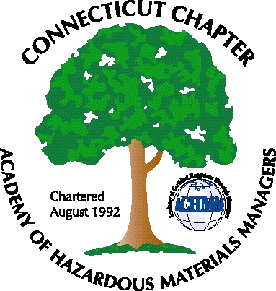 Connecticut Chapter of the

Academy of Certified Hazardous Materials Managers

Minutes of the Board of Directors Meeting

Attendees: Laura Zadrick, Whyndam Abrams, Stuart Manley, John Murray, Stephanie Kelleher-Boyd
February 24, 2017
7:30 AM – 8:45 AM
Agenda –

- Regulatory update: DEEP is issuing used wiper rule, public comment due March 6. Incorporation of hazardous waste generator improvements rule will require legislative approval and may take longer than the EPA-mandated two years. The Massachusetts GHG emissions reports deadline has been extended, this report may no longer be required. Public hearing on CHMM incorporation into the Comprehensive General Permit likely late April, actual date to be determined.
- Last General Meeting – A regulatory update was presented by Paul Simonnetta/Whyndam (Update on CHMM incorporation into several recently proposed wastewater General Permits), Laura Zadrick (new TSCA), and John Murray (OSHA 300 log changes), and was well attended.
- Next General Meeting discussed, desired to be a tour of a local manufacturer. John and Stephanie will reach out to their contacts.
- Website activities –need follow-up on use of new software.
- Newsletter timing – Need to follow up with member who has volunteered to assist.
- New Members/active membership: 8-10 annual Chapter dues checks have been received, expected to increase with National dues payments, and first General Membership meeting.
- Treasury Update – balance is approximately $3500.
- Mail-No activity.
- Open discussion: It was noted that, anecdotally, real estate transactions are picking up.

The meeting was adjourned at 8:45 AM.

-Respectfully Submitted by Whyndam Abrams, Secretary-CTACHMM

