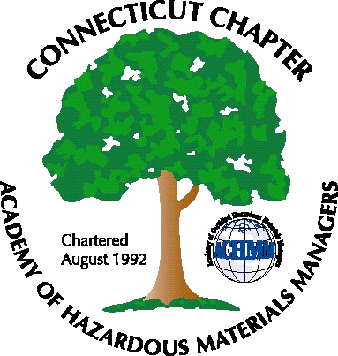 Connecticut Chapter of the

Academy of Certified Hazardous Materials Managers

Minutes of the Board of Directors Meeting

Attendees: Whyndam Abrams, Stuart Manley, John Murray, Stephanie Kelleher-Boyd, Thomas Orlando
November 10, 2017
7:30 AM – 9:00 AM
Agenda –
- Regulatory Update – No new regulations to discuss, however it was noted the Department of Public Health has been performing more inspections. Water contamination issue in Western Massachusetts was discussed.

- The upcoming General Membership meeting is scheduled for December 7, 2017 at J Timothy’s was discussed. Whyndam Abrams and Laura Zadrick will present their recent experiences with DEEP Inspections. John will send another reminder.

- Next General Membership meeting will be scheduled for early next year. Topic may be Tier II updates, tour of Yale co-generation plant, tour of New England Brewery, or tour of a winery in Portland. John and Whyndam will follow up.

- Stephanie will be assuming the Presidency of the Chapter in January. Vice President position will be open. Thomas Orlando attended the BOD meeting and expressed interest in further participation on the Board.

- Treasury update. Recent balance below $1,000, however Chapter dues from National are now being direct-deposited.

- Stuart will obtain updated Expression Web software for home computer to be able to edit the CTACHMM website, and to be able to post the weekly Job Postings as a back-up.

The meeting was adjourned at 9:00 AM.

-Respectfully Submitted by Whyndam Abrams, Secretary-CTACHMM

