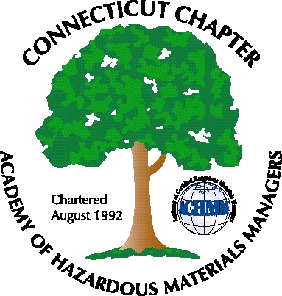 Connecticut Chapter of the

Academy of Certified Hazardous Materials Managers

Minutes of the Board of Directors Meeting

Attendees: Laura Zadrick, Whyndam Abrams, Stephanie Kelleher-Boyd, Stuart Manley, John Murray, Paul Simonetta
August 19, 2016
7:30 AM – 8:45 AM
Agenda –

- Regulatory update: TSCA bill has been signed into law by the President. Batteries exemption as articles remain. MS4 and Industrial stormwater permits are set to be reissued next year. Diversion General Permits most likely will be extended. EPA is working on lead exposure criteria.
- Last General Meeting on Biocontainment at Baystate Health Systems was fairly well attended. Presentation was at Arcadis in Manchester, CT.
- Upcoming General Meeting – A regulatory update will be presented by Paul Simonnetta (various environmental issues), Laura Zadrick (new TSCA), and John Murray (OSHA 300 log changes)
- Future General Meeting will be holiday party in December, topic(s) to be determined
- Website activities –will be updated with next general membership meeting
- Newsletter timing – Need to follow up with member who has volunteered to assist.
- New Members/active membership: 32 paid members. Membership increased with the last General Membership meeting registration.
- Treasury Update – balance increased with last General Membership meeting.
- Mail-One check for $20 was received.
- Open discussion: Whyndam will be the Chapter delegate at the National Conference.

The meeting was adjourned at 8:45 AM.

-Respectfully Submitted by Whyndam Abrams, Secretary-CTACHMM

