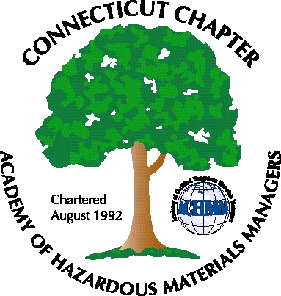 Connecticut Chapter of the

Academy of Certified Hazardous Materials Managers

Minutes of the Board of Directors Meeting

Attendees: Laura Zadrick, Whyndam Abrams, Nick Zackeo, Gene Metti, John Murray, Paul Simonetta
June 24, 2016
7:30 AM – 8:30 AM
Agenda –

- Regulatory update: TSCA bill has been forwarded by U.S. Congress to the president for signature. CT S.B. 301 regarding spill reporting has been signed and will be effective Oct. 1, 2016, and requires DEEP to write spill reporting regulations including reportable quantities.
- Last General Meeting: “Tracing the Nickel, Life Cycle of Recycled PET Bottle” presentation was well attended.
- Regional Call Update: Regional calls cover a larger region to increase participation. The New England Chapter (Boston) and the New Jersey Chapter have been active.
- Upcoming General Meeting – Baystate Medical Center presentation, by John Murray, on biocontainment for highly infectious diseases, scheduled for July 21st. The meeting will be at Arcadis offices in Manchester, CT.
- Future General Meeting – Possible presentation on the recent TSCA bill. Paul could do a presentation on the Miscellaneous General Permit. The recertification process could be future presentation.
- Website activities –will be updated with next general membership meeting
- Newsletter timing – Need to follow up with member who has volunteered to assist.
- New Members/active membership: 20 paid members. Of this, 2 are new members, and 2 are returning members (not members in 2015). Membership is expected to increase with the next General Membership meeting, which will be sent to the 173 valid email addresses on file.
- Treasury Update – Tabled.
- Mail-One check for $20 was received.
- Open discussion: OSHA had a summit meeting in Amherst on June 23. Whyndam will be the Chapter delegate at the National Conference.

The meeting was adjourned at 8:45 AM.

-Respectfully Submitted by Whyndam Abrams, Secretary-CTACHMM

