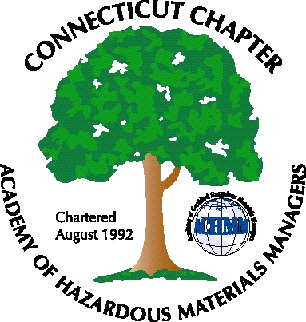 Connecticut Chapter of the

Academy of Certified Hazardous Materials Managers

Minutes of the Board of Directors Meeting

Attendees: Laura Zadrick, Whyndam Abrams, Nick Zackeo
March 4, 2016
7:30 AM – 8:30 AM
Agenda –

- Regulatory update: Discussed as topic for next General Membership meeting
- Last General Meeting: “Tracing the Nickel, Life Cycle of Recycled PET Bottle” presentation was well attended.
- Upcoming General Meeting – Brokerage of Waste and New regulations/changes may be a possible topic, with Nick Zackeo and Stephanie Kelleher-Boyd as possible presenters.
- Future General Meeting – Possible biocontainment presentation at Baystate Medical Center-will need to follow-up with John Murray
- Website activities –On-line event registration still not functional.
- Newsletter timing – Need to follow up with member who has volunteered to assist.
- New Members/active membership: Tabled
- Treasury Update – Tabled.
- Mail-needs to be picked up.
- Open discussion: AHMP Leadership changes discussed.

The meeting was adjourned at 8:45 AM.

-Respectfully Submitted by Whyndam Abrams, Secretary-CTACHMM

