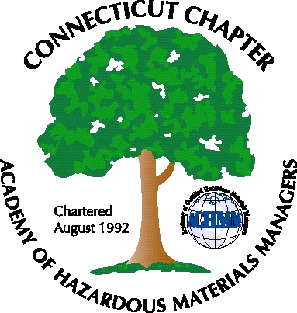 Connecticut Chapter of the

Academy of Certified Hazardous Materials Managers

Minutes of the Board of Directors Meeting

Attendees: Laura Zadrick, Whyndam Abrams, Stuart Manley, Paul Simonetta, Gene Metti
December 2, 2016
7:30 AM – 8:45 AM
Agenda –

- Regulatory update: New hazwaste Generator rules have been issued. Federal vs. state requirements for timeline discussed. CTACHMM will be meeting with the CTDEEP on several days over the next two weeks (Dec. 6th, 12th, and 14th) to discuss incorporation of the CHMM credential into new/modified Wastewater General Permits, consistent with our incorporation into the Miscellaneous General Permit.
- Last General Meeting on Biocontainment at Baystate Health Systems was fairly well attended. Presentation was at Arcadis in Manchester, CT.
- Upcoming General Meeting (December 6, J Timothy’s) – A regulatory update will be presented by Paul Simonetta/Whyndam (Update on CHMM incorporation into several recently proposed wastewater General Permits), Laura Zadrick (new TSCA), and John Murray (OSHA 300 log changes)
- General Meeting will be holiday party in December
- Website activities –discussed using alternate pre-built software, i.e. WIX. Present website has formatting issues, but does work fairly well on phones and tablets.
- Newsletter timing – Need to follow up with member who has volunteered to assist.
- New Members/active membership: 26 paid members for 2016, down from 40 in 2015. Membership may increase with the new management team at the National office.
- Treasury Update – balance remains steady.
- Mail-No activity.
- Open discussion: Discussion for nominations for President and expiring officers. Renewals through IHMM website are time-consuming and fee payment reminders are not consistent.

The meeting was adjourned at 8:45 AM.

-Respectfully Submitted by Whyndam Abrams, Secretary-CTACHMM

