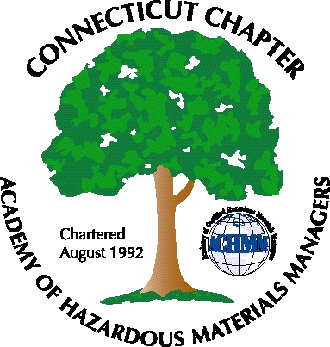 Connecticut Chapter of the

Academy of Certified Hazardous Materials Managers

Minutes of the Board of Directors Meeting

Attendees: Stuart Manley, Laura Zadrick, Whyndam Abrams, Paul Simonetta
September 18, 2015
7:30 AM – 9:00 AM
Agenda –

- Regulatory update: Dam Safety General permit is in draft. GPLPTE draft has been finalized. RICE MACT/NESHAP requirements in effect for generators. Small MS4 storm sewer permit issued. Landfills in Massachusetts for contaminated soil are closing.
- Last General Meeting: Nanotechnology presentation was well attended.
- Upcoming General Meeting – Menu being finalized for September 18, 2015 meeting, at J Timothy’s. Topic will be climate change and sea level rise.
- Future General Meeting – Possible presentation on recycling deposit process for cans and bottles
- Website activities – Hosting server was phased out due to software change from Microsoft Frontpage to ExpressionWeb. Reloaded pages to ExpressionWeb server. On-line event registration still not functional.
- Newsletter timing – Need to follow up with member who has volunteered to assist.
- New Members/active membership: Tabled for next meeting
- Treasury Update – Will try to maintain Chapter balance below $5000 for tax purposes .
- Open discussion: Gene Metti served as Chapter delegate for National meeting in Scottsdale and wrote meeting update, which has been posted to website. Discussed possibility of hosting RCRA and DOT training.

The meeting was adjourned at 9:00 AM.

-Respectfully Submitted by Whyndam Abrams, Secretary-CTACHMM

