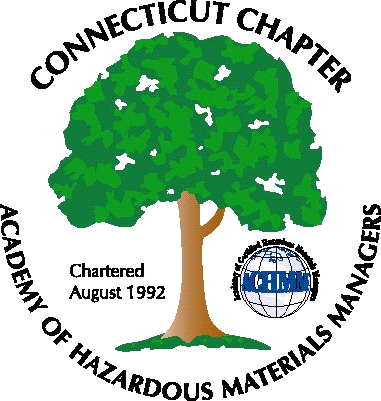 Connecticut Chapter of the

Academy of Certified Hazardous Materials Managers

Minutes of the Board of Directors Meeting

Attendees: Stuart Manley, Laura Zadrick, Whyndam Abrams,
April 10, 2015
7:30 AM – 8:30 AM
Agenda –

- Regulatory update: Battery bill is in legislative voting process. Draft Dam Safety Regulations with Emergency Action Plan for public comment. DEEP seeking input on preliminary draft of Food Preparation Establishment General Permit.
- Last General Meeting: Nanotechnology presentation was well attended.
- Upcoming General Meeting – Attending New Britain Rockcats baseball game being investigated. Will look for possible dates.
- Future General Meeting – Seeking ideas for early fall meeting
- Website activities – Certification class at Field Safety posted to website. Nanotechnology presentation posted as well.
- Newsletter timing – Need to follow up with member who has volunteered to assist.
- New Members/active membership: We have received several inquiries on joining the Chapter. Request for dues sent out to active membership.
- Treasury Update – Chapter balance is same as previous quarter at approximately $4500.
- Open discussion: State Corporation registration due May 1 (completed). Chapter tax return due May 15th (submitted). Chapter delegate still needed for National meeting in Scottsdale.

The meeting was adjourned at 8:30 AM.

-Respectfully Submitted by Whyndam Abrams, Secretary-CTACHMM

