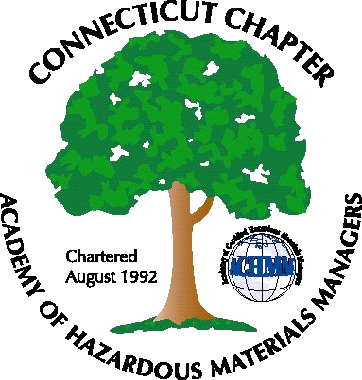 Connecticut Chapter of the

Academy of Certified Hazardous Materials Managers

Minutes of the Board of Directors Meeting

Attendees: Stuart Manley, Laura Zadrick, Nick Zackeo, Whyndam Abrams, Paul Simonetta, Gene Metti, Christie Sunderrajan

January 16, 2015
7:30 AM – 9:00 AM
Agenda –

- Regulatory update
-EPA multi-sector Storm Water General Permit available
- Last General Meeting: Lithium Battery Presentation, as well as previous 2014 General Membership meetings, were well attended.
- Regional Call Update: Scheduled for January 23, 2015, Laura will call in.
- Upcoming General Meeting – Planned Nanotechnology presentation on March 26, 2015. Will likely be held at J Timothy’s.
- Future General Meeting – Will try to schedule meeting for June. Suggestions included tour of Up John clean-up site or tour of South Central Connecticut Regional Water Authority.
- Website activities – Need outreach to any members proficient in web design.
- Newsletter timing – Plan for after next General Meeting.
- New Members/active membership: Tabled.
- Treasury Update – Chapter balance is approximately $4500.
- Open discussion: State Corporation registration due May 1. Chapter tax return due May 15th. Laura will write Chapter annual report for National. Chapter delegate needed for National meeting in Scottsdale.

The meeting was adjourned at 9:00 AM.

-Respectfully Submitted by Whyndam Abrams, Secretary-

