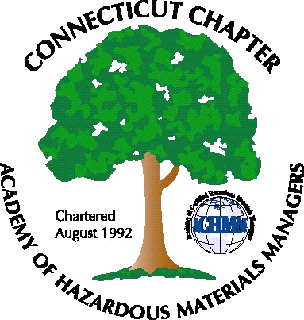 Connecticut Chapter of the

Academy of Certified Hazardous Materials Managers

Minutes of the Board of Directors Meeting

Attendees: Stuart Manley, Laura Zadrick, Whyndam Abrams, John Murray, Nick Zackeo
December 4, 2015
7:30 AM – 8:45 AM
Agenda –

- Regulatory update: GPLPTE has been issued. ezFile now required for UST Forms, however DEEP still has to take paper forms. Several states have adopted pharmaceutical waste as Universal waste rules.
- Last General Meeting: “Climate Change and Sea Level Rise” presentation was well attended.
- Upcoming General Meeting – Will be December 8, 2015 at Hearthstone Pub. Topic will be Beverage Container Deposit System and PET Recycling.
- Future General Meeting – Possible biocontainment presentation at Baystate Medical Center
- Website activities –On-line event registration still not functional.
- Newsletter timing – Need to follow up with member who has volunteered to assist.
- New Members/active membership: 39 Paid members in 2015, down 14 from 2014. 4 new members, however 3 of these were 2013 members.
- Treasury Update – Bank Balance is $2700.
- Mail-needs to be picked up .
- Open discussion: The Connecticut Business climate and Commission on Economic Competiveness was discussed. It was mentioned that hazardous waste inspectors are conducting audits of compactors.

The meeting was adjourned at 8:45 AM.

-Respectfully Submitted by Whyndam Abrams, Secretary-CTACHMM

