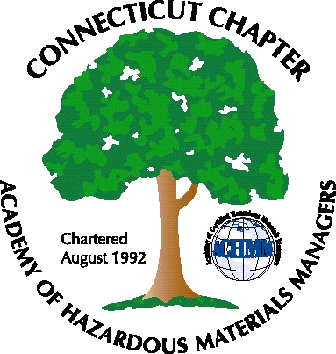 Connecticut Chapter of the

Academy of Certified Hazardous Materials Managers

Minutes of the Board of Directors Meeting

Attendees: Stuart Manley, Laura Zadrick, Nick Zackeo, Whyndam Abrams

September 5, 2014
7:30 AM – 9:00 AM
Agenda –

- Regulatory update
-Possible future CT battery recycling bill.
-Lithium battery ground shipping regulations possible in 2015
- Last General Meeting: As requested by several members, a tour, of Solvent Recovery Services remediation site, was well-attended.
- Regional Call Update: Several chapters meet monthly or every other month. Outings include baseball games and other social activities.
- Upcoming General Meeting – Tesla Model S test drive and presentation by Tesla is planned for October 23, 2014.
- Future General Meeting – Holiday meeting planned for December 9, 2014, topic to be determined.
- Website activities – Need outreach to any members proficient in web design.
- Newsletter timing – Plan for after next General Meeting.
- New Members/active membership: For 2014 there are 43 current members year-to-date. 6 are new members. 15 former members from 2013 have not renewed for 2014.
- Treasury Update – Chapter balance is 4757.35. An additional Square reader has been obtained for accepting payments.
- Open discussion: Should reach out to chapter member who did attend National meeting to get feedback. Need call for nominations for 2014 elections. Sign up web page should be re-designed to require registration first, to get to the payment page.

The meeting was adjourned at 9:00 AM.

-Respectfully Submitted by Whyndam Abrams, Secretary-

