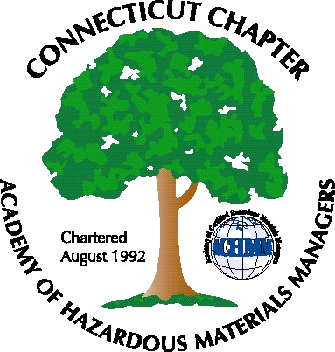 Connecticut Chapter of the

Academy of Certified Hazardous Materials Managers

Minutes of the Board of Directors Meeting

Attendees: Stuart Manley, Laura Zadrick, John Murray, Whyndam Abrams

June 6, 2014
7:30 AM – 9:00 AM
Agenda –

- Regulatory update
-Clean Water Act 316b rule signed, pertaining to cooling water intake from navigable waters
-Federal proposal of guideline to cut carbon pollution from existing power plants
-State alliance to put 3.3 million zero-emission vehicles on the road.
-Unilever pays 4.5 million for violating Clean Water Act, for not reporting treatment system bypass.
-DEEP release reporting criteria to be risk based.
- Last General Meeting: What went well, what needs improvement. Due to last minute speaker cancellation, presentation was abbreviated. Venue remains popular, but a tour was requested, instead of another presentation, for next meeting.
- Regional Call Update: Chapters trying to recruit more members. Tennessee chapter gets free space from local business, NYPenn have one day intro course at university, to attract students. Several chapters meet monthly.
- Upcoming General Meeting – Tour of SRS clean-up site is planned.
- Future General Meeting – Tesla electric car test drive possible. Possible locations at Yale West Haven campus, UTC Farmington, GE.
- Website activities – Will be updated for next General Membership meeting.
- Newsletter timing – Summer newsletter needs to be written.
- New Members/active membership- Chapter membership is at around 42 members. 37 are renewals, 5 are new. It was noted 13 members from 2013 did not rejoin.
- Treasury Update – Chapter balance around $4600.

The meeting was adjourned at 9:00 AM.

-Respectfully Submitted by Whyndam Abrams, Secretary-

