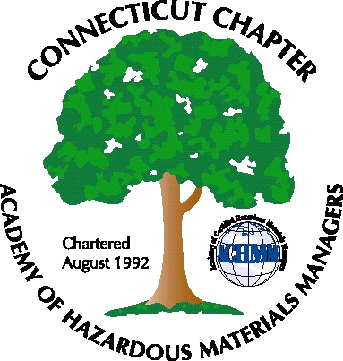 Connecticut Chapter of the

Academy of Certified Hazardous Materials Managers

Minutes of the Board of Directors Meeting

Attendees: Whyndam Abrams, Stuart Manley, Gene Metti, , Laura Zadrick, Nick Zackeo

March 7, 2014
7:30 AM – 9:00 AM
Agenda –

- Regulatory update – Risk-based clean-up criteria is moving forward. Organic waste composting rule may affect some facilities. Boiler energy assessments due 3/21, for affected bouilers, with reports to EPA due in July.
- Last General Meeting – It was noted that the last General Meeting was very well attended. J. Timothy’s appears to be a convenient central location for Chapter members.
- Regional Call Update – Laura has previously distributed the minutes from the recent Regional call.
- Upcoming General Meeting- Several ideas were discussed, including Klean Energy tour, SRS clean-up site tour, Marina environmental issues tour, Duracell Natural Disaster Drill, and California Universal Waste rule and retail enforcement issues. Nick will get back to the group on a presentation of the latter two topics. April 3 is possible date.
- Next General Meeting (following quarter): One of the tour sites may be selected, for outside activity in the warmer weather
- Website Activities- Recent email outage was rectified. All emails to contactus@ctachmm.org are now cc’d to Board officers and John Murray.
- Newsletter timing – Most likely after next General Membership meeting
- New Members/active membership- Chapter membership is at around 30 members. Membership should increase on sign-ups for meetings.
- Treasury Update – The Chapter operated at a slight loss last year, but funds are still relatively high
- Mail- Has been checked recently, membership one check received.

The meeting was adjourned at 9:00 AM.

-Respectfully Submitted by Whyndam Abrams, Secretary-

