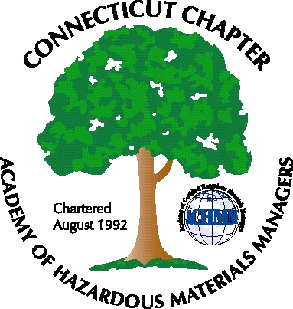 Connecticut Chapter of the

Academy of Certified Hazardous Materials Managers

Minutes of the Board of Directors Meeting

September 6, 2013
7:30 AM – 9:00 AM

- CTDEEP MISC Water Permit Update – The existing MISC General Permit expires on October 30, 2013, however a draft incorporating CTACHMM comments has not been received by the Chapter.
- Last General Meeting on the transformation of the remediation program was well attended – thanks Stuart. CTDEEP is next expected to act on the spill reporting requirements.
- Next General Meeting – Winery Tour Cancelled due to scheduling conflicts with the National Conference. Possible presentation ideas for next meeting include RICE MACT/NESHAP, waste rag updates, and combustible dust issues.
- Website Activities – website is updated weekly with job postings
- Survey to be developed for ideas to attract more members. Networking with colleges such as RPI, University of New Haven discussed.
- Developing a new logo was discussed, possibly to incorporate national organization changes.

The meeting was adjourned at 9:00 AM.

-Respectfully Submitted by Whyndam Abrams, Secretary-

