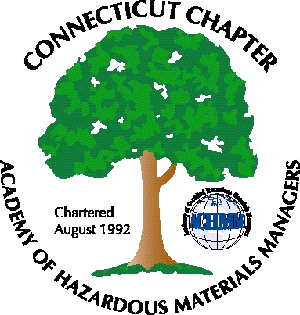 Connecticut Chapter of the

Academy of Certified Hazardous Materials Managers

Minutes of the Board of Directors Meeting

May 31, 2013
7:30 AM – 9:00 AM

Attending: Laura Zadrick, Gene Metti, Whyndam Abrams, Stuart Manley, John Murray, Paul Simonetta, Stephanie Boyd, Christie M. Sunderrajan

- New PO Box in Plainville has been obtained, new Chapter mailing address is:
CTACHMM
PO Box 604
Plainville, CT 06062

Old mailbox will be closed. Letterhead (completed), website (completed), business card, and AHMP and IHMM updates need to be completed

- The CBIA Environmental Conference, June 19th in Waterbury was discussed as a marketing opportunity. However it was later determined this conference does not have vendor booths, but this conference link has been added to the CTACHMM website.

- Next General membership Meeting will be an update of the CTDEEP Clean-up program transformation, June 25th, at J. Timothy’s in Plainville, CT. Attendance sign up was checked, nine attendees have registered.

- Fall General Membership meeting was discussed; a possible winery tour may be scheduled for September. It was mentioned that a central Connecticut location would be preferable. A tour of Kleen Energy in Middletown was discussed as a possible winter tour.

- Website Activities. It was noted exam preparatory course link needs to be updated. October course in Meriden, CT link replaced this link. This information was also forwarded to an individual who contacted the Chapter inquiring about a CHMM prep class. Operating Plan needs to be updated.

- Treasury Update – 2012 Tax return has been filed. It was noted that it is in the Chapter’s best interest for tax purposes to continue to keep Chapter accounts under $5,000.

- College outreach was discussed as a future year goal.

The meeting was adjourned at 9:00 AM.

-Respectfully Submitted by Whyndam Abrams, Secretary-

