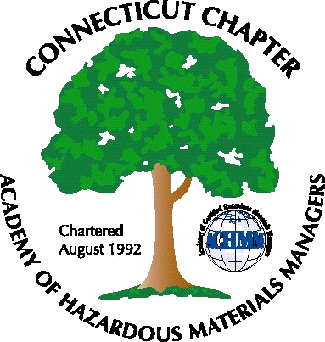 Connecticut Chapter of the

Academy of Certified Hazardous Materials Managers

Minutes of the Board of Directors Meeting

March 1, 2013
7:30 AM – 8:30 AM

Directors Participating: Laura Zadrick, Gene Metti, Whyndam Abrams, Stuart Manley

- CTDEEP MISC Water Permit Update – Status of this permit draft was discussed. Follow-up with Art Mauger, CTDEEP indicates a draft is almost completed. CTDEEP will distribute to CTCHMM for review and determination on Public Hearing will be made at that time.

- UST – DEEP Passed Public Act 12-1; new financial requirements. This was discussed as a possible topic for a future General Membership meeting.

- Next General membership Meeting will be an update of the Global Harmonization System (GHS), March 20, 2013, at Duracell in Bethel, CT. Attendance sign up was checked, nine attendees has registered. John will be requested to send out a reminder email (done, 3/4/13).

- CTACHMM will have a booth at the April 24, 2013 CBIA Safety Fair, at the Farmington Club in Farmington. Booth display will be needed from IHMM. Several Board members will be able to man the booth.

- Website Activities. It was noted National Conference Link needs to be updated. Orlando 2013 link added.

- Newsletter. John will be requested to send an email requesting articles (done, 3/4/130.

- New Members – tabled

- Treasury Update – Stuart will look into electronic transfer of dues from National.

- Open Discussion – College outreach was discussed. Annual business filing and tax return will be prepared by Whyndam and Stuart, respectively.
.

The meeting was adjourned at 8:30 AM.

-Respectfully Submitted by Whyndam Abrams, Secretary-

