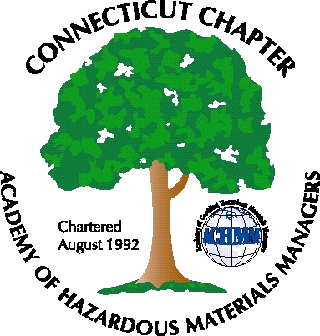 Connecticut Chapter of the

Academy of Certified Hazardous Materials Managers

Minutes of the Board of Directors Meeting

September 7, 2012
7:30 AM – 8:30 AM

Directors Participating: Laura Zadrick, Gene Metti, Whyndam Abrams, Stuart Manley, John Murray, Mathew Twerdy

- CTDEEP MISC Water Permit Update – A revised draft has not yet been received from CTDEEP. The latest communication with DEEP staff indicated a draft will be finished by the end of the year.

- UST – DEEP Passed Public Act 12-1; new financial requirements. The impact of the phase-out of the state financial assurance mechanism was discussed. Also discussed was the recent amendment to the UST regulations requiring Class A, B, and C operators, as well as new requirements for new tanks, and increased inspections of existing tanks. An article will be written for the summer newsletter.

- Next General membership Meeting will be September 25th, at Baystate Medical Center, with a presentation on Green Healthcare Buildings, and tour to follow. John Murray will follow-up on catering options and member/non-member cost.

- Upcoming General membership Meeting ideas – Matt Twerdy has contacted Connecticut Resources Recovery for a possible tour of its single-stream recycling facility.

- GHS update – Implementation of this standard will begin next year, so another possible topic for a later meeting would be a presentation on OSHA’s new hazard communication standard, adopting the GHS standard. CBIA GHS training will be posted on web-site.

- Website Activities – website postings will be updated to remove past event notices

- Newsletter– Summer newsletter will be completed by Sept. 14th.

- New Members – 57 members have paid their 2012 dues. 17 2011 members have not yet paid 2012 dues, and will be contacted by John Murray. Laura will follow up to ensure she is notified when CT-affiliated CHMMs obtain certification.

- Treasury Update – Stuart Manley reported that there is $3884 in the Chapter account.

- Open Discussion – Chapter involvement in state or regional meetings that have tradeshow booth availability was discussed. ASSE New England Chapter will be having a meeting at the end of November, John Murray will send link.
.

The meeting was adjourned at 8:30 AM.

-Respectfully Submitted by Whyndam Abrams, Secretary-

