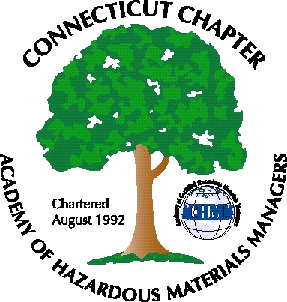 Connecticut Chapter of the

Academy of Certified Hazardous Materials Managers

Minutes of the Board of Directors Meeting

June 1, 2012
7:30 AM – 9:00 AM
Olympia Diner, Newington, CT

Directors Participating: Laura Zadrick, Gene Metti, Whyndam Abrams, Stuart Manley, John Murray, Stephanie Kelleher-Boyd, Nick Zackeo

AGENDA

- CTDEEP MISC Water Permit – Whyndam reported that DEEP is still working on draft MISC permit language. It may be several months before a draft is available.
- Next General membership Meeting – Will be June 27, at Arcadis in Manchester, CT. The topic will be “When Phase I Environmental Site Assessments Go South, and the Principle of Unintended Outcomes” Nick will look into restaurant options.
- The Fall General Membership meeting is tentatively scheduled for September 25, at Baystate Medical Center, topic to be Green Guide for Health Care/LEED Building, with tour to follow. John will look at catering options.
- Winter meeting topic may be the new OSHA HazCom standard (Global Harmonization System), possibly presented by Proctor & Gamble or Heritage Environmental.
- Website Activities – installation of web hit counter will be tried by Stuart. Links for next General Membership meeting will be set-up.
- New Members –Paid membership is at 52, and it was noted that 11 of the 2011 members have not paid their 2012 dues. Sign-ups for the next General Membership meeting should increase membership.
- Treasury Update – Stuart indicated the Chapter has about $4,000, sufficient for operations, Chapter delegate travel support, and possible community activity.
- AHMP – Anchorage, Alaska – Sept.9-13 - Chapter Delegate duties will be offered to other BOD members, if no takers, will be opened up to general membership.
- Open Discussion- Will look for environmental-related community event to sponsor, to increase the Chapter’s visibility. Chapter mailbox was discussed. Stephanie will take over checking the box; in the future the mailbox may be moved to a more central location.
.

The meeting was adjourned at 9:00 AM.

-Respectfully Submitted by Whyndam Abrams, Secretary-

