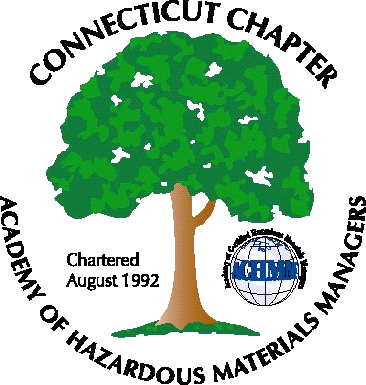 Connecticut Chapter of the

Academy of Certified Hazardous Materials Managers

Minutes of the Board of Directors Meeting

March 2, 2012
7:30 AM – 8:30 AM
Olympia Diner, Newington, CT

Directors Participating: Laura Zadrick, Gene Metti, Whyndam Abrams, Stuart Manley, John Murray, Paul Simonetta,

AGENDA

- Annual Report – Laura has completed the annual report for AHMP. She should be receiving emails from them directly now.
- CTDEEP MISC Water Permit Letter – The Chapter met with DEEP, which went generally well. We will be submitting a follow-up comment letter by March 15th.
- Next General membership Meeting – Discussion of either inviting DEEP to present the new Streamflow regulations, or tour of Green Healthcare building at the Baystate Medical Campus in Springfield. John to discuss with Nick.
- Website Activities – Use of StarChapter was discussed. It was agreed that we are still too small to justify the initial and monthly expense.
- New Members – Two new members have joined. Paid membership is up to 48, 46 pay through national, 2 have paid directly. We expect paid membership to reach around 60 by mid-year.
- Treasury Update – Stuart indicated the Chapter has about $3400, expected to increase to $3700 by mid-year. There should be sufficient funds to have a CTACHMM booth at a local conference. CBIA and CCM were mentioned as possible organizations that may have conferences.
- AHMP – Anchorage, Alaska – Sept.9-13 - Stephanie Kelleher-Boyd will not be able to attend as Chapter delegate. Opened to other BOD members or could be offered as incentive to future BOD members.
- Open Discussion- Stuart noted that the remediation standard regulations update has been tabled by DEEP until next January. When issued, expected to follow Massachusetts model: by contamination level, not by basis of transfer act “establishment.”
.

The meeting was adjourned at 8:30 AM.

-Respectfully Submitted by Whyndam Abrams, Secretary-

