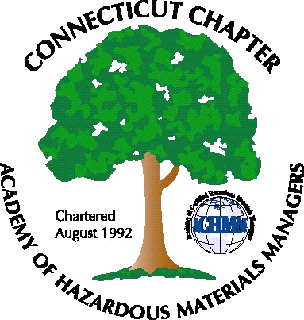 Connecticut Chapter of the

Academy of Certified Hazardous Materials Managers

Minutes of the Board of Directors Meeting

June 3, 2011
7:30 AM – 8:45 AM

Directors Participating: Laura Zadrick, Whyndam Abrams, Stuart Manley, John Murray
Also attending: Stephanie Boyd

AGENDA

1. Discuss proposed dates for next General Membership Meeting: A tour of a single-stream recycling plant is being investigated.
2. CTDEP General Permits/Regulatory Activity: Whyndam mentioned the newly proposed construction stormwater General Permit.does not include provision for CHMM sign-off of SPCP Plans. However, this may not an activity that CHMMs would want to be included in.
3. Whyndam reported spring newsletter has been published, distributed, and posted to website
4. Whyndam reported the annual Secretary of State business filing has been completed.

5. Stuart reported the IRS tax return has been filed. It is posted on the website as well
6. Finance: Stuart reported Chapter finances are doing well. There are 63 paid CTACHMM members year-to-date.
7. Whyndam attended on-line demonstration of the StarChapter program. StarChapter integrates most Chapter membership, contact, dues, meeting, and website functions into one program. However, startup costs and monthly fees are fairly high for a chapter of our size.
8. Renaming of the Chapter to incorporate the change to AHMP was discussed. Secretary of State and IRS registration would have to be amended, as would web address, email, and logo. Logo redesign options and possible contest was discussed.

The meeting was adjourned at 8:45 AM.

-Respectfully Submitted by Whyndam Abrams, Secretary-

