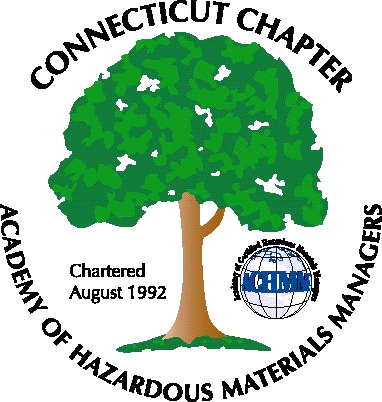 Connecticut Chapter of the

Academy of Certified Hazardous Materials Managers

Minutes of the Board of Directors Meeting

March 4, 2011
7:30 AM – 8:45 AM

Directors Participating: Matthew Twerdy, Laura Zadrick, Whyndam Abrams, Stuart Manley, John Murray

AGENDA

1. Discuss options/ideas for next General Membership Meeting: A Stormwater Permit update dinner meeting for April was discussed (possibly at Arcadis). Future General Membership meetings ideas were a tour of a single stream recycling facility, Yale Co-gen, or Kaman. Meeting announcements will be sent to CBIA attendee list
2. CTDEP General Permits/Regulatory Activity: Stuart mentioned that the Connecticut Environmental Forum, which meets the 1st Wedneday of every month, in Wethersfield, is a good resource for regulatory updates.
3. Operating Plan: Matt will prepare operating plan for the year.

4. Review Course: Review Courses will be offered by Field Safety Corporation in April, depending on enrollment. When details are finalized, John will distribute to email list and CBIA attendance list.
5. Website Activities: It was suggested a link to Upcoming events be posted to the Home page.
6. Finance: Finances are at steady-state. There are 59 paid CTACHMM members year-to-date.
7. Newsletter: Matt will contact newsletter editor regarding plans to continue. If not, new editor will be selected.
8. The CBIA conference that CTACHMM had a booth (provided by IHMM) at was well attended (approximately 250 attendees). DEP mentioned the CHMM credential, generating interest in our booth and obtaining the certification.

The meeting was adjourned at 8:45 AM.

-Respectfully Submitted by Whyndam Abrams, Secretary-

