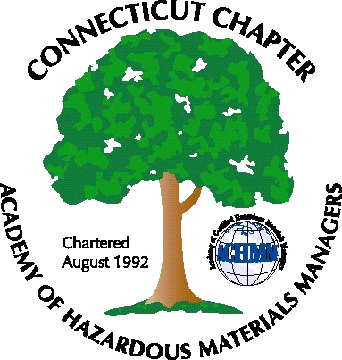 Connecticut Chapter of the

Academy of Certified Hazardous Materials Managers

Minutes of the Board of Directors Meeting

December 2, 2011
7:30 AM – 9:00 AM
Olympia Diner, Newington, CT

Directors Participating: Laura Zadrick, Gene Metti, Whyndam Abrams, Stuart Manley, John Murray, Paul Simonetta, Nick Zackeo Also attending: Stephanie Kelleher Boyd

AGENDA

1. New Board Members/Change in Board members for 2012: Election for Secretary and Vice President/President Elect will be conducted this month. The board only received one nomination for each position, but a formal election will be conducted on-line.

2. Annual Report: Outgoing President Mathew Twerdy has given a copy of last year’s report to Laura, who will complete the report in January.

3. Next General Membership Meeting. Several possible topics were discussed, including presentation on revised RSRs, Cogen tour at Yale, and single-stream recycling tour.

4. CTDEEP Regulatory Activity: Stream flow regulations have been approved by Legislative Review Committee. Draft MISC Permit has been published.

5. Review Course: John will reach out to Field Safety to offer distribution of training dates to CTACHMM members.

6. Website Activities: Gene has reviewed website and has several useful suggestions that will be implemented.

7. Finance/Taxes: The Chapter received an IRS late filing fee penalty, which was in error. Stuart contacted the IRS and has closed this issue. Chapter finances show a balance of approximately $2800. CTACHMM will consider worthwhile activities with these funds, such as sponsoring a booth at a local conference or community projects.

8. AHMP Activities: National Conference will be next year in Anchorage, Alaska
.

The meeting was adjourned at 9:00 AM.

-Respectfully Submitted by Whyndam Abrams, Secretary-

