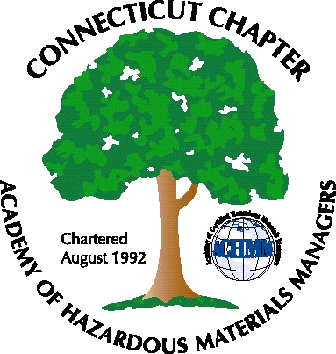

Connecticut Chapter of the

Academy of Certified Hazardous Materials Managers

Minutes of the Board of Directors Meeting

October 22, 2010
7:30 AM – 8:45 AM

Directors Participating: Matthew Twerdy, Whyndam Abrams, Stuart Manley, Paul Simonetta

AGENDA

1. 2011 potential officers: Paul will contact John Murray to review membership list to determine potential interested parties. An e-mail will be sent to the membership requesting nominations/volunteers for Board positions
2. Discuss options/ideas for next General Membership Meeting: A regulatory update dinner meeting for early December was discussed. Matt will investigate site options, and Stuart will look into a speaker. Paul or Whyndam may be able to give part of the update.
3. CTDEP General Permits/Regulatory Activity: Stormwater Multi-Sector permit has been issued. GPLPTE is still awaiting re-registration forms. CHMM have been listed as authorized to make permeability determinations for secondary containment systems, under the proposed Release Reporting regulations.
4. AHMP National Conference Report: Matt was CT Chapter delegate and attended all-day Chapter information sessions. Much useful information was gained, and an incorporation and legal issues guide was distributed.

5. Review Course: Review Courses continue to be offered by Field Safety Corporation, depending on enrollment
6. Website Activities: Addition of active links, i.e. EPA daily updates, was discussed. On-line meeting enrollment is working well.
7. Finance: Stuart reported that spending has been well-controlled for this year, no issues.
8. Newsletter: Matt will contact newsletter editor (Elsa Payne) regarding plans for next newsletter.
9. AHMP Activities: AHMP has Chapter information available on their website.

The meeting was adjourned at 8:45 AM.

-Respectfully Submitted by Whyndam Abrams, Secretary-

