CT Chapter Newsletter |  |  | Newsletter Date  Volume 3, Issue 1
CT Chapter of the ACHMM

Special Interest Articles
Meet the New Board Members.
Your Chapter Survey Results.
2005 Chapter Operating Plan.

Individual Highlights
President’s Letter 1
New Board Members 2
Treasurer’s Report 3
RSR Seminar 3
CHMM Course 4
Conferences 4
Operational Plan 5
Survey Results 5
Mold Seminar Pics 6
Regulatory News 7
Directory 8
 | President’s Letter
As the incoming President of your Chapter, I’d like to let you all know that I am here to serve you in any way I can and invite your participation as much as possible. To that end, we will be focusing on more communication with our members to let you know what your Board is doing in the hopes that you will let us know what you are thinking and finding out what is important to you. I thank you for filling out the 2005 Chapter Survey. Send me a message at any other time. Our operating plan is included in this newsletter. We will update it for you as we set definite dates.
Last year, under the direction of our then President, Susan Katz and the Board of Directors, we put on a number of events based on the results from a member survey conducted late in 2003. While participation at these events was not tremendous, the feedback from the attendees was positive. I encourage those of you who attended these events to spread the good word. These events are also important because they often qualify for Continuing Maintenance Points (CMP’s) which are important when it comes time to renew your certification.
I want to personally thank Susan Katz on behalf of all our members for her service as President. She was a very active leader and most notably initiated a member survey that I think will become an annual event. It is important to solicit feedback from the members so that we serve their needs. Sue continues to be involved as a Past-President member of the Board and I look forward to working with her in the coming year.
Other Board membership news includes the departure of Heather Galarneau as Secretary and we now welcome Winston Brown to replace her. As you may recall, there were no candidates for Secretary that were submitted during the November 2004 election. The position remained vacant until February 2005 when Winston’s nomination could be confirmed. We also welcome John Rie as Vice President who was nominated in November and was unopposed. He has already shown himself an energetic participant.
Looking forward, we hope to revamp our Chapter website this year so that it is kept current and useful to our members. We have assembled an enthusiastic committee headed by Paul Simonetta.
We are kicking off this year with a General Membership Chapter Dinner meeting on March 15, 2005. Please plan to attend to meet the Board members and to hear about the plans for 2005 activities. Nick Zackeo will speak to us about how our credential is important to those of us working in Connecticut. Based on the positive feedback from the Mold Seminar held last November, we’ve asked John Murray to give us a brief version of his presentation. The food at the Yankee Silversmith in Wallingford is always good and Rose Coggeshall does a great job in making all the arrangements. I look forward to seeing you there.
Elsa Payne, CHMM

Getting to  Know  Our  Newest  Board Members. | Winston Brown, Secretary
Getting to  Know  Our  Newest  Board Members. | Winston is a native of Jamaica. Winston has an extensive background in Fire Safety. He spent five years in the US Air Force as an Aircraft Crash Rescue/Fire Protection Specialist. Upon leaving the Air Force, Winston worked as a Hartford Firemen for over three years.  Winston has held various positions with Northeast Utilities including work at Millstone Nuclear Power Station where he worked as a Site Engineer. | His current position is Division Environmental  Coordinator, where he is responsible for the coordination of all  environmental issues at the Division level.  Winston has his two undergraduate degrees (Fire Science Technology and Fire Protection Engineering) and his Masters (Industrial Hygiene) from the University of New Haven.  He also completed an Associate Certificate in | Project Management through The George Washington University, where he is currently a candidate for the Master Certificate in Project Management.  Winston is listed in the Outstanding Young Man of America, and Who's Who in the East publications for 1988 and 1991, respectively.  Winston is single. He enjoys tennis, the arts, music, literature, science and architecture.
Getting to  Know  Our  Newest  Board Members. | John E. Rie, VP/President-Elect
Getting to  Know  Our  Newest  Board Members. |  | John is Founder and President of CBRS, Inc. (CT Bioremediation Services) located in Southington, CT. John’s firm was co-founded to clean up sites, air, and water contaminated with liquids and solids, using bioremediation, phytoremediation and other innovative technologies. John is also an expert witness in CERCLA actions.  John has an undergraduate degree in Chemistry from the University of Vermont in  Burlington, VT and a doctorate in Organometallic Inorganic Chemistry from Wayne State University in Detroit, Michigan.  John has an extensive background and experience in the field of chemical research and development. He has traveled internationally. John lived abroad (Germany) as a Pilot Plant Manage for Hoechst. He also has experience as a sales, product and technical manager.  John was recently the Adjunct Lecturer/Professor at both the University of New Haven and Quinnipiac University in Hamden, CT.  John is a member of Sigma Xi (scientific honor society) and has published a number of papers.
Getting to  Know  Our  Newest  Board Members. | President, Elsa Payne
Getting to  Know  Our  Newest  Board Members. | Elsa is the current president of the Connecticut Chapter of ACHMM and the Environmental Protection Specialist at the Plum Island Animal Disease Center located on Plum Island, NY. She has been managing the Environmental Program at Plum Island for the USDA (and now U.S. Dept. of Homeland Security) for the past six years which included environmental assessments of the 840-acre property and its buildings and several permitted facilities. She received a Bachelor of Science degree in Environmental Engineering from the University of Hartford in 1982 and a Master of Science in Mechanical Engineering degree from the University of Connecticut in 1990. She has worked in the fields of aircraft engine fuel pumps manufacturing, submarine sonar and hydroacoustics research prior to her tenure at Plum Island. She’s a life-long resident of Connecticut currently residing in Old Saybrook with her husband and three teenagers.

Treasurer’s Report: For 2004
STARTING BALANCE: $2227.44
DEPOSITS: $1782.00
EXPENSES: ($2810.57)
________
ENDING BALANCE: $1198.87

Deposit Summary: From Dues: 1590.00
From Dinner: 192.00
TOTAL: 1782.00
Expense Summary:
PO Box Renewal: 96.00
Postage for 2003 Ballots: 38.48
Dinner Meeting: 499.31
BOD Conference Calls: 867.60
Domain Renewal: 134.91

Expense Summary (cont’d):

CBIA Conference: 800.00
Honorariums: Textbooks 130.00
CBIA Conf. Materials: 14.68
CTACHMM Banner: 127.09
Green Bldg. Luncheon 52.50
Honorarium: Dinner Cert. 50.00
TOTAL: 2810.57

 | RSR Seminar  The Environmental Professionals’ Organization is hosting a full-day seminar on the Remediation Standard Regulations (RSR) on April 5, 2005 - Hartford Marriott/Rocky Hill, Rocky Hill, CT. The instructor is Elsie Patton of the CT DEP.  Connecticut's Remediation Standard Regulations apply to  actions taken to remediate polluted soil or a ground-water plume at or emanating from a release area pursuant to Chapter 445 or 446k of the General Statutes, or to Public Act 95-183 or Public Act 95-190 including but not limited to any such action required to be taken or verified by a  Licensed Environmental Professional (LEP).  This seminar has been designed as two separate parts of instruction -- the first part (morning session) will be devoted to those aspects of the RSR that are related to soils; the second part (afternoon session) will include those sections of the RSR that apply to groundwater, including the regulations related to Environmental Land Use Restrictions.  The Connecticut State Board of Examiners of Environmental Professionals has approved this course for 8.0 hours of continuing education credits (CTLEP-005 rev.), [as well as CHMM CMP’s]. | The course will be of significant use to any practitioner who must use the RSR in the course of their professional activities to evaluate the environmental condition of properties throughout Connecticut. It has also been designed for those individuals who are planning to take the upcoming exam for Licensed Environmental Professionals.  Registration will begin at 7:30 AM, the program runs from 8 AM - 5 PM. A continental breakfast and full lunch will be served. The Hartford Marriott/Rocky Hill is located at 100 Capitol Blvd., in Rocky Hill, CT (860) 257-6000. The Marriott is located off I-91 Exit 23, on the east side of the highway.  The cost is $200 for EPOC members; $250 for non-members (includes continental breakfast and lunch). For Gov't/Student rate call EPOC. Payment is due on the date of the program. Cancellations and substitutions are accepted; however, you will be billed whether or not you attend the seminar unless you cancel by contacting EPOC prior to 4/3/05.  For further information or questions, contact Seth Molofsky at (860) 228-2492, E-mail

CHMM Review Course
Whether you are interested in being an instructor (earn CMP’s) or passing the word onto those who are preparing for the CHMM certification exam, there will be a review course offered by Field Safety at the University of New Haven on April 25, 26, and 27, 2005. Contact Mike Ziskin at Field Safety at (203) 483-6003 or www.fieldsafety.com for registration details.
The CHMM certification exam will be May 23, 2005. Please contact Field Safety or ihmm.org for exam registration information. Keep in mind that registering for an overview course does not automatically make you eligible to take the CHMM exam. You must file an application with IHMM six weeks prior to the exam date.

Dinner Meeting
Start earning your CMP’s! Join us for the Spring General Membership dinner meeting being held on Tuesday, March 15, 2005 at the Yankee Silversmith in Wallingford, CT
The Social starts at 6:00PM, Dinner at 6:30 PM, Speakers at 7:30 PM and Chapter Business at 9:00 PM. The Yankee Silversmith is located just off the Merritt Parkway; (203) 269-5444.
The presents are members of our Chapter!
John Murray will present on Mold. Nick Zackeo is presenting on CHMM Certifications, Wastewater General Permits and Aquifer Protection Regulations in CT. Elsa Payne will review Chapter business and upcoming events for 2005.
RSVP to Rose Coggeshall by 9 March with your dinner selection.

Upcoming Conferences
Ergonomics Conference
University of New Hampshire
March 28-29, 2005
(603)862-4344

AIChE 2005 Global Congress on Process Safety
April 10-14, 2004
Atlanta, GA
(800)242-4363

AIHce 2005 Conference
Anaheim, California
May 21-26, 2005
www.aiha.org/aihce.htm

ASSE 2005 Conference
New Orleans, LA
June 12-15, 2005
www.asse.org/safety2005.htm

National Workers’ Compensation and Occupational Medicine Conference
Cape Cod, MA
July 18, 19-21, 2005
www.seak.com

ACHMM 2005 Conference
St. Louis, MO
Sept 25-29, 2005
www.achmm.org

2005 Chapter Operational Plan  March  - General Membership Dinner Meeting – March 16  - Regulatory Update  - CBIA EH&S Conference – March 31  April  - Board of Directors Planning Meeting- Olympia Diner- April 1st  - Regulatory Update  May  - Board of Directors Planning Meeting-Olympia Diner- May 6th  - Mid-month conference call-TBD  - Seminar - TBD  - Regulatory Update  June  - Board of Directors Planning Meeting-Conference call-June 3rd  - General Membership Meeting/Seminar – TBD  - Regulatory Update  - Seminar - TBD  July  - Board of Directors Planning Meeting-Olympia Diner- July 8th  - Mid-month conference call- TBD  - Regulatory Update  August  - Board of Directors Planning Meeting-Olympia Diner-August 5th  - Mid-month conference call-TBD  - Regulatory Update  September  - ACHMM National Conference Sept 25-29  - Board of Directors Planning Meeting – Olympia Diner-September 9th  - Mid-month conference call-TBD  - Nomination of CTACHMM Officers and Directors for 2006  - Regulatory Update  - Seminar - TBD  October  - Board of Directors Planning Meeting-conference call-October 7th  - General Membership Meeting/Seminar –TBD  - Elections for CTACHMM Officers and Directors for 2004  - Regulatory Update  November  - Board of Directors Planning Meeting-Olympia Diner- Nov. 4th  - Results from 2004 election for CTACHMM Officers and Directors (by November 15th)  - Mid-month conference call-TBD  - Seminar -TBD  - Regulatory Update  December  - General Membership Meeting/Seminar - Dinner (informal - End of Year Review)  - Annual Reporting to National Academy  - Board of Directors Planning Meeting-conference call-December 2nd  - Regulatory update  The purpose of a newsletter is to provide specialized information to a targeted audience. Newsletters can be a great way to market your product or service,. |  |  | WHAT’S  THE  PLAN  FOR  2005?!

Annual Chapter Survey Results
Our Chapter conducted a survey of our membership to get a sense of what is important to them. The Board of Directors and Committees will use the results of this survey to plan Chapter events for 2005 and focus our attention to meeting the expectations of our members. The following survey results are based on approximately 50% of the members as that is how many responded to the survey.
The top three meeting preferences were Seminars,” Breakfasts” and Trips.

Members wanted more Chapter correspondence, networking events, notices of upcoming educational events, and regulatory news updates.
There was a unanimous response for a better Chapter website.
Topics of interest for upcoming seminars, in descending order were:
Waste Management, Connecticut RSRs, Conceptual Site Modeling,
Communication Skills, and
PCB Management.

Please continue to provide feedback to your Board members. Don’t wait for a survey. Let us know if we are not asking the right questions.

Thanks to those who participated and encourage the rest of our members to provide feedback at any time.

Mold Seminar

Photos are from the Mold Seminar hosted by the Chapter last Fall. Attendees earned CMP’s!
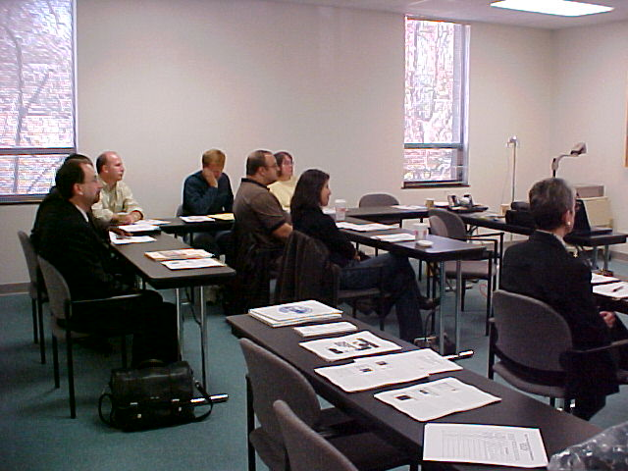

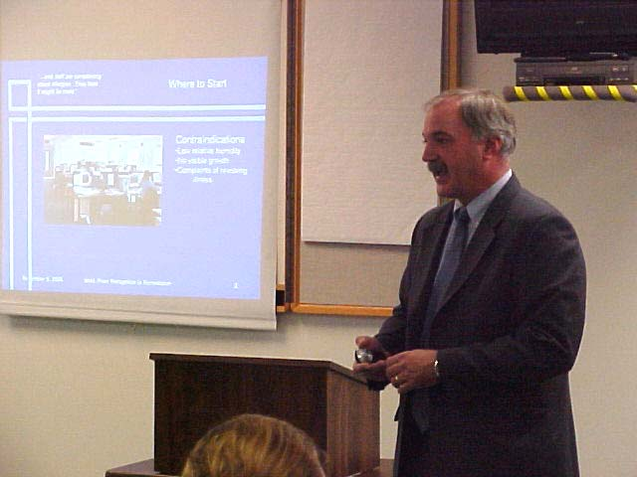
Seminar Organizer and Presenter:
John Murray

` 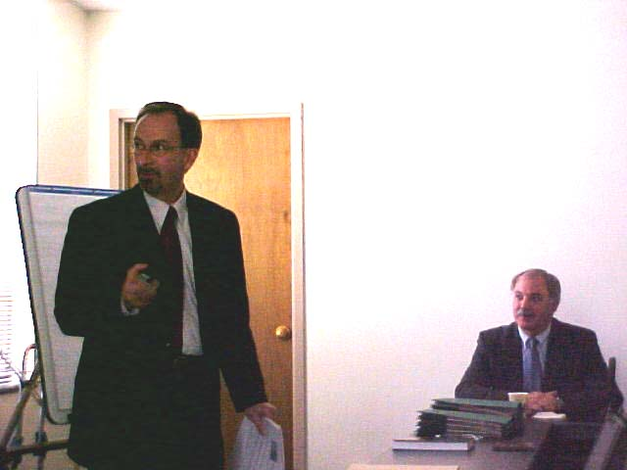 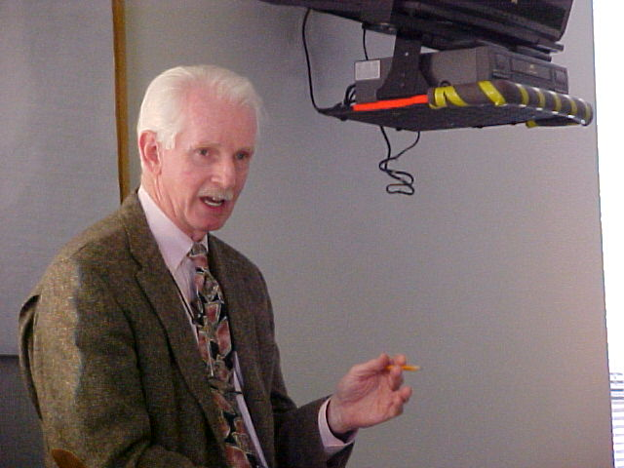

Presenter: Robert Bourgeault (on right)
Presenter: John Bannon

March  is International Science  Month | In the News
On January 26, 2005, the EPA proposed changes to the periodic reports that chemical companies provide to the EPA on substances they produce. Under TSCA, the EPA proposed a rule that would require companies who import or manufacture 25,000 lbs or more per year at any plant site they own or control to report every five years instead of the current four years. For chemicals produced in volumes of over 300,000 lbs per years, manufacturers would have to provide information only on domestic processing and use, not data on activities that take place outside of the United States.
The National Toxicology Program released its 11th edition of the “Report on Carcinogens” where 17 substances were added to its list. For the first time viruses are on the list: hepatitis B and C and some human papilloma viruses. Other additions to the list include lead and all lead compounds, x-rays, three heterocyclic amines, cobalt sulfate and several substances used in paints, inks and textile dyes. Find the full report on http://ntp.niehs.nih.gov.
 | Revamping Material Safety Data Sheets
In response to mounting criticism, OSHA has undertaken several measures that are expected to improve Material Safety Data Sheets (MSDSs). In fact, poorly prepared MSDSs have been cited as a contributing factor in several fatal US chemical industry accidents
In March 2004, OSHA issued its findings in a report that indicates concerns “regarding the quality of information disseminated, in particular, whether information is consistently accurate on MSDSs.”
One focus for OSHA will be to develop new guidance documents for complying with hazardous communication requirements.
More importantly will be OSHA’s attempt to develop a MSDS quality-control component for MSDSs whereby OSHA compliance officers will use a template developed for various chemicals and identify critical information for inclusion on their MSDS. When MSDSs in the field are compared to these templates and found to be deficient, OSHA will notify manufacturers of the deficiencies in their MSDS.
Another consideration for OSHA is the adoption of the Globally Harmonized System of Classification & Labeling of Chemicals as a long-term solution for improving HAZCOM. The chemical safety sheet is nearly identical to the ANSI standard for a MSDS, but the new system would standardize wording and convey information more consistently than current MSDS. This system was adopted by the United Nations in 2002 and the UN’s goal is to have it fully operational by 2008.

We hope you enjoy reading the newsletter and find the topics pertinent and interesting. The newsletter is a “living” document that is constantly evolving. Please feel free to submit any articles that fellow members would enjoy reading by the following dates: 8 April 05, 10 June 05, 12 Aug 05, 14 Oct 05 and 9 Dec 05. Digital photos are always welcome.  I’d like to thank the following for their submissions for February’s newsletter: Winston Brown, John Murray, Elsa Payne, and John Rie. Regulatory articles are courtesy of ACS’s Chemical & Engineering News.  Send your submissions to:  Rose Coggeshall at rosecog@sbcglobal.net  Board Members and Chairs for 2005  President  Elsa Payne, CHMM  Plum Island Animal Disease Center  Route 25  Orient Point, NY 11957  (631)323-3380  EPAYNE@piadc.ars.usda.gov  Vice-President/President-Elect  John E. Rie, CHMM  48 Panorama Dr.  Southington, CT 06489  (860)628-9470  johnrie@cox.net  Secretary  Winston Brown, CHMM  brownwd@NU.com  Treasurer  Rosemary Coggeshall, CHMM  PO BOX 220  Uncasville, CT 06382  (860)848-4140  rosecog@sbcglobal.net  Past President  Susan Katz, CHMM  susan.katz@pw.utc.com  Membership Chair  John Murray, CHMM  John.Murray@bhs.org  Newsletter Editor  Rose Coggeshall, CHMM  rosecog@sbcglobal.net  Regulatory Affairs  Mattew Twerdy, CHMM  mtwerdy@fando.com  Web Page Administrator  Karen Thompson, CHMM  karen.thompson@trincoll.edu  Web Page Committee Chair  Paul Simonetta, CHMM  psimonetta@tritonenvironmental.com  Your Tagline here.  We’re on the Web!  See us at:  www.ctachmm.org | From the Editor
 | About Our Organization
 | Chartered in 1992, the CT Chapter of the Academy of Certified Hazardous Materials Managers is affiliated with the National Academy. The Chapter is a non-profit professional organization that has 82 up-to-date members. For more information about the Chapter, please visit its official website at www.ctachmm.org |  | To become active in the Chapter (and earn CMPs), contact any Board member for more information.
CT ACHMM Chapter members
CT ACHMM
PO BOx 220
Uncasville, ct 06382

