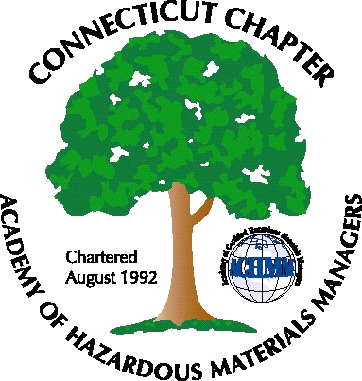Connecticut Chapter
of the
Academy of Certified Hazardous Materials Managers
Mailing Address: CTACHMM P.O. Box 220 Uncasville, CT 06382
www.ctachmm.org

Board of Directors

President
Elsa Payne, CHMM
Plum Island Animal Disease Center
P.O. Box 848
Greenport, NY 11944
(203)245-7744

Vice President/President Elect
Dr. John Rie, CHMM
CBRS Inc.
P.O. Box 2709
Meriden, CT 06450
(203) 237-1383

Secretary
Winston D. Brown, CHMM
Connecticut Light & Power
49 Randolph Road
Middletown, CT 06457
(860) 638-2343

Treasurer
Rosemary Coggeshall, CHMM, CSP
rosecog@earthlink.net
(860) 848-4140

Past President/Director At Large
Susan Katz, CHMM
Pratt & Whitney
400 Main St. m/s 169-16
East Hartford, CT 06108
(860) 565-7146

Director At Large
Paul Simonetta, CHMM
Triton Environmental, Inc.
741 Boston Post Road Suite 101
Guilford, CT 06437
203-458-7200

Membership Chairman
John Murray, CHMM, CSP, CIH
Baystate Health Systems
759 Chestnut Street,
Safety Office P5901
Springfield, MA 01199
(413) 794-5494

Government Affairs Chairman
Matthew Twerdy, CHMM
Kaman aerospace
old windsor road.
bloomfield, CT 06002
(860) 243-7258

To: Mr. Mike Harder
Bureau Chief – Bureau of Waste Management
CT Department of Environmental Protection
79 Elm Street
Hartford, CT 06106

Re: UST Third Party Certifications – CHMM Qualifications

Dear Mr. Harder: Thank you for taking the time to meet with our group in August to discuss the Certified Hazardous Materials Manager (CHMM) credential. We want to continue to keep in contact with you regarding the development of new programs at the DEP. We are providing this letter to formally respond to your request for information regarding the CHMM credential and DEP’s intended program for 3rd party certification of Underground Storage Tanks (UST) system inspections. Specifically, we wanted to provide you with information detailing why we believe individuals with the CHMM credential are well qualified to participate in these inspections.

CHMMs are required to be knowledgeable on a wide range of environmental topics. One of the specific areas that CHMMs are trained and tested is USTs. The recommended CHMM exam study guide is the Hazardous Materials Management Desk Reference published by the Academy of Certified Hazardous Materials Managers (ACHMM). Chapter 21 of the Desk Reference is dedicated to the topic of USTs. In addition, USTs are identified as a specific testing topic for the CHMM Certification exam (see Page 2 of the attached CHMM Exam Blueprint).

Based on discussions within our CTACHMM membership, CHMMs have been involved with USTs in Connecticut including providing guidance on UST compliance, auditing UST records and systems, and responding to Notices of Violations (NOVs). We understand the certification program will likely include a review of recordkeeping associated with UST compliance such as tank tightness testing, product inventory logs, and cathodic protection systems. However, the CHMM certification is not intended to be synonymous with a professional engineering certification. As such, we believe that CHMMs would not be qualified to certify UST construction materials (e.g. steel or fiberglass tanks/piping) or installation of a UST system. Based on our discussions, we believe that the certification program that the DEP intends to develop is primarily “compliance” related and would therefore, not require an engineering type of review or certification.

Thank you for your consideration. As described above, we believe that CHMMs are well qualified to participate in 3rd party certification of UST system inspections. Should you have any questions or require any additional information, please feel free to contact me.

Sincerely,

Elsa Payne, CHMM
President, CTACHMM

enclosure
CC: academy@achmm.org

